National Links
https://www.whitehouse.gov/wp-content/uploads/2021/01/National-Strategy-for-the-COVID-19-Response-and-Pandemic-Preparedness.pdf
https://covidactiongroup.net/
https://www.covidcollaborative.us/
Rockefeller new plan

CALIF State Testing Lab
https://testing.covid19.ca.gov/wp-content/uploads/sites/332/2020/11/CDPH-Valencia-Branch-Laboratory-Playbook.pdf
Perkin Elmer lab - sesntive PCR test (swab only based?)
Color providing digital - just raised $167M for last mile healthcare
CA Safe Schools $2B https://youtu.be/DmHNwJalkPg?t=1000
Naomi Bardoch point person from UCSF
https://www.cdph.ca.gov/Programs/OSPHLD/LFS/Pages/COVID-19Guidance.aspx#
https://testing.covid19.ca.gov/covid-19-testing-task-force-laboratory-list/

Memphis and Poplar
https://covid19.memphistn.gov/test-to-protect/
Lists Poplar and 2 other labs
Home swabbing video
Looks like they are using Steripak swabs
https://dailymemphian.com/article/17167/how-memphis-medical-lab-poplar-healthcare-mobilized-to-right-covid
Dr. Manoj Jain, a local infectious disease physician, advising the city on its COVID-19 response
Jim Sweeney - CEO Poplar
https://www.phc-covid.com/organization/pod-testing/

Ginkgo
5 week pilot 100's https://twitter.com/jrkelly/status/1341852769918078976
Ned says internall called pooled swabbing "Randy method"
Shared them on detailed prodecured for swabbing and on-site pooling (get link)
Looks like they are using green shaft cleanroom swabs (*ask Christina)
https://www.concentricbyginkgo.com/our-plan-to-provide-simple-affordable-testing-to-every-school-in-america/
Looks like they are planning this as a sample collection program far beyond their own NGS test
"Scalable: Existing labs running individual molecular tests (i.e. PCR) can also run pooled samples. This means pooling could multiply our existing testing capacity by twenty times or more"

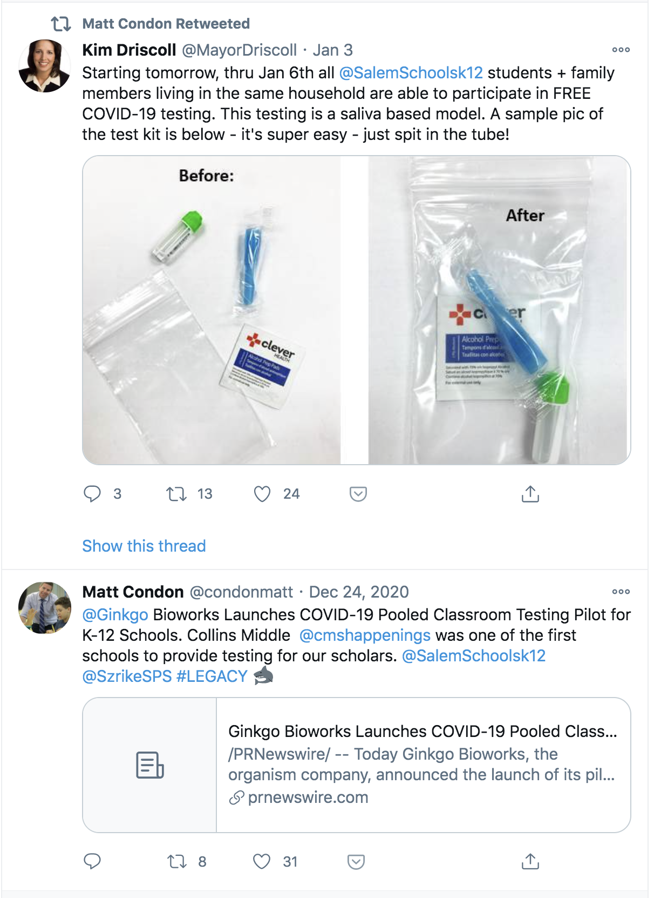
Dueling projects, Salem has connections

NSV
https://www.glenbard87.org/covid-19-surveillance-faq/
https://www.safeguardscreeningllc.com/ Ed Campbell saliva LAMP testing company

JCMA
provides software and logistics solution for school testing, takes care of running entire program and delivers tubes to labs to run
Google Doc on JCMA

Darwin Biosceinces
Colorado

O'Connor
https://openresearch.labkey.com/wiki/Coven/page.view?name=field-testing
https://openresearch.labkey.com/wiki/Coven/page.view?name=antigen_testing_schools

Wellesley Schools in Mass
https://wellesleyps.org/viral-testing/
“WPS COVID-19 Pool Surveillance Testing”
“DO YOUR PART: Help Schools Start & Stay in Person”
Contracted with Mirimus Saliva Clear website

Once a week, on a designated morning, each staff member and student picks up their barcoded SalivaClear sample collection kit from school. They register it via a Google Form, entering in their barcode number and their consent agreement. They then self-collect their saliva sample (guided by visual and video instruction materials), seal it, and immediately return it to the school staff.

The samples are then transported to a Mirimus clinical lab, where they are pooled and tested the same day. Any pools that test positive will be immediately retested at a pool level of 2 samples.

The school is notified of any pair of samples that contains a positive result, and the 2 people in that pair are directed to obtain a physician’s order for a diagnostic COVID test. The diagnostic tests may be performed by Mirimus (which uses the MeentaSafe reporting platform) or by another clinical lab.

Mirimus
Mirimus Saliva Clear website
uses the MeentaSafe reporting platform

Mass Schools
Massachusetts Dept of Education Memo - Jan 8
https://covidedtesting.com/pooled-testing-in-watertown-public-schools

UnitedHealth Group Visby School Pilot

UnitedHealth Group Calculator and Plans
https://calculator.unitedinresearch.com/complex_dashboard

Rockefeller
Rockefeller - Dec20 Plan SHARED
Covid-19 Antigen Testing in K-12 Schools: Early Lessons from Six Pilot Sites

ICGEB NEB Gates LAMP project in Africa
https://www.icgeb.org/gates-foundation-to-fund-icgeb-collaboration-with-new-england-biolabs/
https://www.icgeb.org/icgeb-cape-town-covid-19-diagnostic-testing-activities/
https://www.icgeb.org/wp-content/uploads/2020/03/Protocol002_Covid19_RT_qPCR.pdf

https://www.cnbc.com/2020/04/29/coronavirus-testing-chief-says-no-way-on-earth-us-can-test-5-million-a-day.html

Recent Papers
Curative NP Comparison
BinaxNow MD DPH

